

**Yu-Gi-Oh! Duel-Links! Promotion Website**

Names : Alvin Darmawan Salim(1820010022)

Class : 4SC5

Faculty : Mr. Fachran Nazarullah

**CEP-CCIT**

**FAKULTAS TEKNIK UNIVERSITAS INDONESIA**

**2020**



**Developed By**

1. **Alvin Darmawan Salim**

**PROJECT ON**

*Yu-Gi-Oh! Duel-Links! Promotion Website*

Batch Code : 4SC5

Start Date : 01-05-2020

End Date : 08-05-2020

Name of Faculty : Mr. Fachran Nazarullah

Name of Developer:

1. Alvin Darmawan Salim

Date of Submission: 08-05-2020

**Yu-Gi-Oh! Duel-Links!**

**Promotion Website**



**CERTIFICATE**

This is to certify that this report titled “Yu-Gi-Oh! Duel-Links! Promotion Website” embodies the original work done by Alvin Darmawan Salim. Project in partial fulfillment of their course requirement at NIIT.

Coordinator:

Mr. Fachran Nazarullah

Praise be to Allah Almighty, Most Merciful, because thanks to His grace and guidance, the writer can arrange and present a paper that contains about Yu-Gi-Oh Duel Links! Promotion website. The writer also thanked to Mr. Fachran Nazarullah as lecturer Introductory IT courses that have provided guidance to the writer in the process of preparing this paper. Not to forget the writer thank the various parties who have given encouragement and motivation.

The author realizes that in the preparation of this project there are still many shortcomings and far from perfection. Therefore, the authors expect constructive criticism and suggestions to improve this paper and can be a reference in preparing the papers or subsequent tasks.

The authors also apologize if in writing this paper there are typos and errors that confuse the reader in understanding the author's intent.

.

**ACKNOWLEDGEMENT**

**System Summary:**

Yu-Gi-Oh Duel Links! Promotion website is website that purposed to promoting the game Yu-Gi-Oh Duel Links!

**SYSTEM ANALYSIS**

1. VS Code

Visual Studio Code is a source-code editor developed by Microsoft for Windows, Linux and macOS. It includes support for debugging, embedded Git control and GitHub, syntax highlighting, intelligent code completion, snippets, and code refactoring. It is highly customizable, allowing users to change the theme, keyboard shortcuts, preferences, and install extensions that add additional functionality. The source code is free and open-source, released under the permissive MIT License. The compiled binaries are freeware for any use.

1. Adobe Photoshop

Adobe Photoshop is a [raster graphics editor](https://en.wikipedia.org/wiki/Raster_graphics_editor) developed and published by [Adobe Inc.](https://en.wikipedia.org/wiki/Adobe_Inc.) for [Windows](https://en.wikipedia.org/wiki/Microsoft_Windows) and [macOS](https://en.wikipedia.org/wiki/MacOS). It was originally created in 1988 by [Thomas](https://en.wikipedia.org/wiki/Thomas_Knoll) and [John Knoll](https://en.wikipedia.org/wiki/John_Knoll). Since then, the software has become the industry standard not only in [raster graphics](https://en.wikipedia.org/wiki/Raster_graphics) editing, but in [digital art](https://en.wikipedia.org/wiki/Digital_art) as a whole. The software's name has thus become a [generic trademark](https://en.wikipedia.org/wiki/Generic_trademark), leading to its usage as a verb (e.g. "to photoshop an image", "[photoshopping](https://en.wikipedia.org/wiki/Photoshopping)", and "[photoshop contest](https://en.wikipedia.org/wiki/Photoshop_contest)") although Adobe discourages such use.x

**TOOLS USED**

User Interface Website Preview using Screenshot:

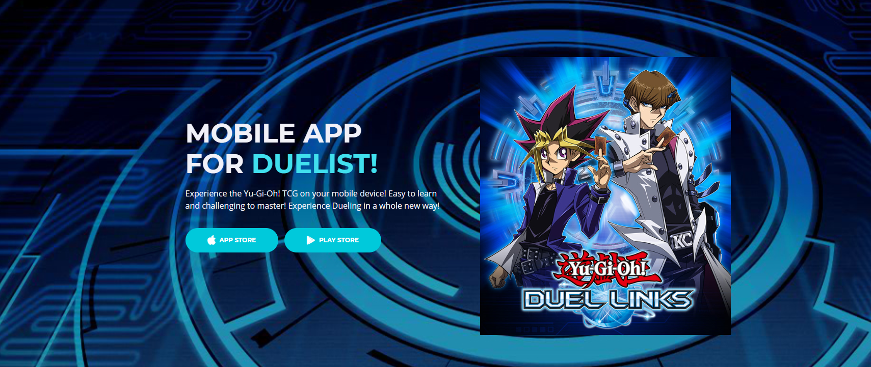

Home Page (Desktop)

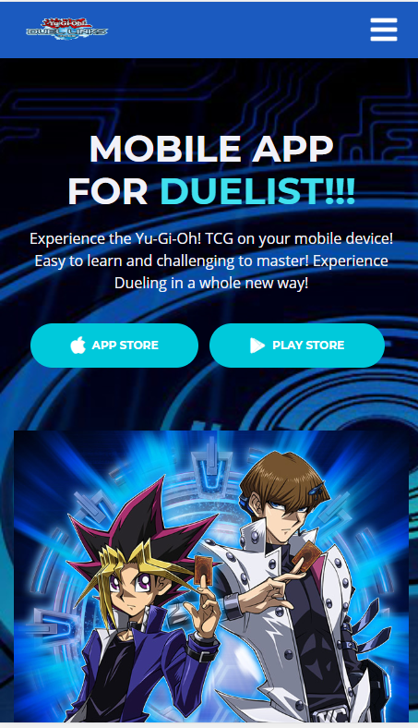

Home Page (Mobile)

**USER INTERFACE**

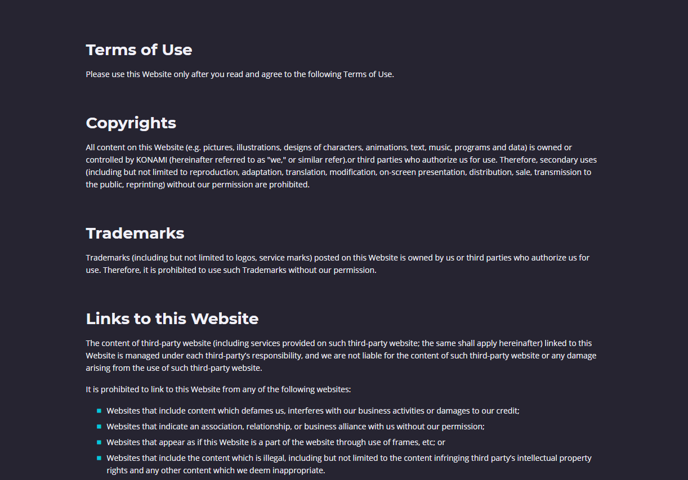

Terms Condition (Desktop)

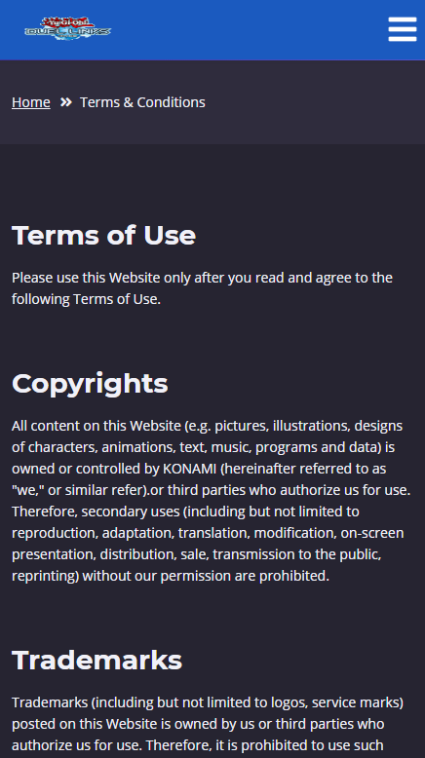

Clinic Service (Mobile)



Privacy Policy (Desktop)

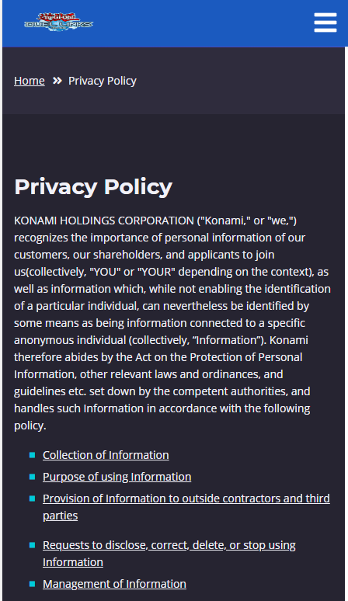

Book Appointment (Mobile)

|  |  |  |  |  |
| --- | --- | --- | --- | --- |
| *No* | *Action Description* | *Planned of Date Completion* | *Actual Date* | *Remarks* |
| 1. | Creating the project | 07-05-2020 | 07-05-2020 |  |
| 2. | Finishing the project | 07-05-2020 | 08-05-2020 |  |
| 3. | Finished all stuff that needed | 07-05-2020 | 08-05-2020 |  |

**ACTIVITY LIST**

**Hardware :**

Intel® Core™ **i7**-8750H processor (9MB cache, up to 4.10Ghz) NVIDIA GeForce GTX 1050Ti with 4 GB of GDDR5.

**Operating System :**

Microsoft windows 10

**Software :**

VS Code

|  |  |  |
| --- | --- | --- |
| **PROJECT FILE DETAILS** | | |
| No | File Names | Remarks |
| 1 | Index.html | Contain page that shows landing page |
| 2 | privacy-policy.html | Contain page that shows privacy policy |
| 3 | terms-conditions.html | Contain page That shows Terms and Conditions |

**CONFIGURATION**